Canada and China
Student’s Name
Institutional Affiliation

Canada and China
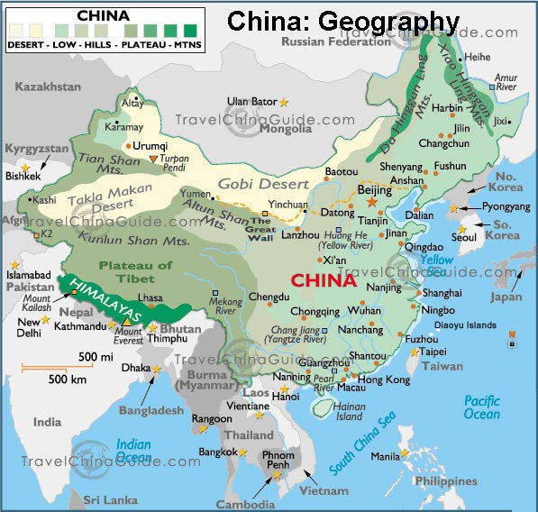
Map with Major Cities and Physical Characteristics

- Size relative to Canada: Canada covers 9.98million square kilometers and China covers 9.98 square miles.
- World Region: Canada is in North America while China is in Asia.
- Capital City: The capital city of Canada is Ottawa while the capital city of China is Beijing.
- Population: Canada has a population of 37,412,852 while China has a population of 1,403,500,365.
- Language (s) spoken: Canadians speak English and French while Chinese speak Standard Chinese, Mongolian, Uyghur, Tibetan, and Zhuang.
- GDP per capita: Canada has a GDP per capita of 59106.97 Canadian Dollars while China has a GDP per capita of 11585.88 Canadian Dollars.
When it is noon in Ottawa, it is midnight in Beijing.
Geographical Background
Climate: Canada has a continental climate that is characterized by cold winters and hot summers.
Labor Force: Canada has a labor force of 19.34 million people that work majorly in agriculture (2%), manufacturing (13%), construction (6%),, services (76%), and others (3%) (Nation Mater, 2019).
Government: Canada had federal constitutional monarchy composes a queen (Elizabeth II), Governor General (Julie Payette), and Prime Minister (Justin Trudeau).
Trade Relations: Canada exports include: mineral fuels, vehicles, machinery, gems and precious metals, wood, plastic and plastic articles, electrical machinery, aircraft and spacecraft, aluminum, and paper while its imports include: vehicles, machinery, electrical machinery, mineral fuels, plastics, optical, technical, and medical equipment, pharmaceuticals, iron and steel articles, furniture, and precious metals.
Trade Relations with China: Canada-China trade relations can be traced back to 1942 when Canada sent an envoy to the China to recognize the People’s Republic of China after the Chinese Civil War. In this regard, China became Canada’s major trading partner in the Asian continent since the latter could export its goods to the Chinese market while import the same for its domestic market. Positive perception of the Chinese by the Canadians facilitated trade between the two countries.
Current Competition: China National is a petroleum corporation that deals in oil and gas. It is ranked fourth in the Fortune Global 500. The company produces approximately54 billion cubic meters of natural gas.
Education opportunities: Major ost-secondary institutions in China include: Fudan University, University of Science and Technology of China, Zheijang University, Najing University, and Sun Yat-sen University.

Reference
Nation Master. (2019). Canada labor stats. Retrieved from
https://www.nationmaster.com/country-info/profiles/Canada/Labor

